PS Task and Control Panel Interface Specification

Date: | 1/23/2003 01:41:00 AM
Version: | 0.1
Document #: | NA

Revision History

Version | Date | Owner | Notes
0.1 | 2/12/02 | Xueli.lv | Creation.

Contents
1 Introduction 5
1.1 Scope 5
1.2 Applicable Documents 5
1.3 Acronyms and Definitions 5
2 OVerview 6
3 call 7
3.1 PS →Control panel 7
3.1.1 MN_SETUP_REQ 7
3.1.2 MN_SETUP_RSP 7
3.1.3 MN_REJ_REQ 7
3.1.4 MN_CALLCNF_REQ 7
3.1.5 MN_ALERT_REQ 7
3.1.6 MN_DISC_REQ 7
3.1.7 MN_REL_REQ 8
3.1.8 MN_START_DTMF_REQ 8
3.1.9 MN_STOP_DTMF_REQ 8
3.1.10 MN_HOLD_REQ 8
3.1.11 MN_RETRIEVE_REQ 8
3.1.12 MN_BUILD_MPTY_REQ 8
3.1.13 MN_SPLIT_MPTY_REQ 8
3.1.14 MN_HOLD_MPTY_REQ 8
3.1.15 MN_RETRIEVE_MPTY_REQ 9
3.1.16 MN_AOC_REQ 9
3.2 Control panel → PS 9
3.2.1 MN_SETUP_IND 9
3.2.2 MN_SETUP_CNF 9
3.2.3 MN_REJ_IND 9
3.2.4 MN_PROGRESS_IND 9
3.2.5 MN_ALERT_IND 9
3.2.6 MN_DISC_IND 10
3.2.7 MN_REL_IND 10
3.2.8 MN_START_DTMF_CNF 10
3.2.9 MN_STOP_DTMF_CNF 10
3.2.10 MN_HOLD_CNF 10
3.2.11 MN_RETRIEVE_CNF 10
3.2.12 MN_SYNC_IND 10
3.2.13 MN_CALL_WAIT_IND 11
3.2.14 MN_CALL_HELD_IND 11
3.2.15 MN_CALL_RETRIEVED_IND 11
3.2.16 MN_BUILD_MPTY_IND 11
3.2.17 MN_SPLIT_MPTY_IND 11
3.2.18 MN_CALL_FORWARD_IND 11
3.2.19 MN_CALL_BARRY_IND 11
3.2.20 MN_AOC_IND 11
4 sms 12
4.1 PS → Control panel 12
4.1.1 MN_SMS_REQ 12
4.2 Control panel → PS 12
4.2.1 MN_SMS_IND 12
5 PARAMETERS CONFIG 13
5.1 System parameters 13
5.2 CALL control 13
5.3 SMS control 13
6 data structure 14
6.1 CALL_NUMBER_T 14
6.2 SMS_CONTENT_T 14
6.3 SMS_USER_DATA_T 14
7 msc 15
7.1 Normal MO call 15
7.2 Normal MT call 16

Introduction

Scope
本文介绍了Dummy PS 和Control panel的接口。

Applicable Documents

Acronyms and Definitions
GSM | Global System for Mobile Communications
GPRS | General Packet Radio System
WCDMA | Wideband Code Division Multiple Access
DSP | Digital Signal Processor

OVerview
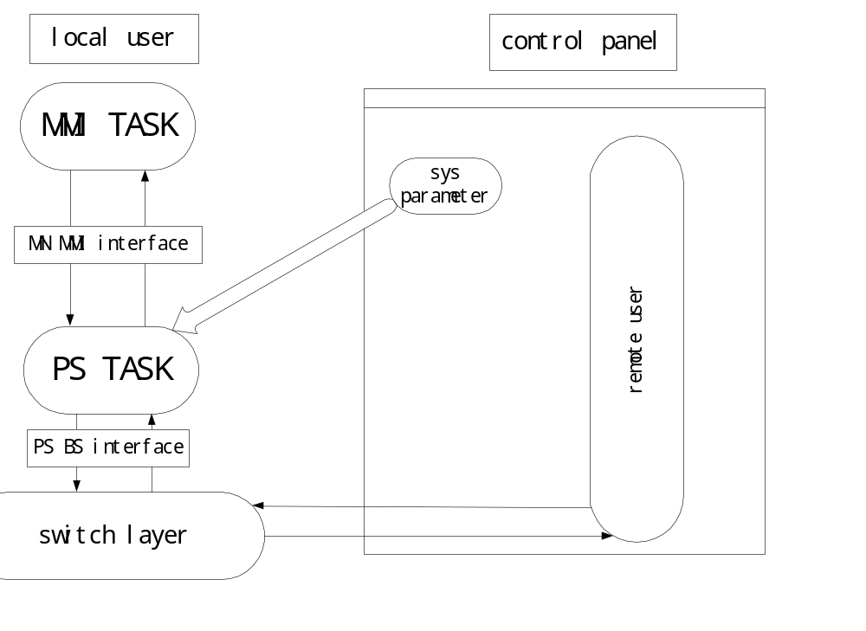

call

PS →Control panel

MN_SETUP_REQ

Filed Type | Filed name | Description
UINT8 | ti
CALL_NUMBER_T | Called_number

MN_SETUP_RSP
Request to read MM data.
Filed Type | Filed name | Description
UINT8 | ti

MN_REJ_REQ
Filed Type | Filed name | Description
UINT8 | ti
GSM_CAUSE_T | cause

MN_CALLCNF_REQ

Filed Type | Filed name | Description
UINT8 | ti

MN_ALERT_REQ
Filed Type | Filed name | Description
UINT8 | ti

MN_DISC_REQ
Filed Type | Filed name | Description
UINT8 | ti
GSM_CAUSE_T | cause

MN_REL_REQ
Filed Type | Filed name | Description
UINT8 | ti
GSM_CAUSE_T | cause

MN_START_DTMF_REQ
Filed Type | Filed name | Description
INT8 | Dtmf_value
UINT8 | ti

MN_STOP_DTMF_REQ
Filed Type | Filed name | Description
UINT8 | ti

MN_HOLD_REQ
Filed Type | Filed name | Description
UINT8 | ti

MN_RETRIEVE_REQ
Filed Type | Filed name | Description
UINT8 | ti

MN_BUILD_MPTY_REQ

Filed Type | Filed name | Description
UINT8 | Active_ti
UINT8 | Held_ti

MN_SPLIT_MPTY_REQ
Filed Type | Filed name | Description
UINT8 | ti

MN_HOLD_MPTY_REQ
Filed Type | Filed name | Description

MN_RETRIEVE_MPTY_REQ
Filed Type | Filed name | Description

MN_AOC_REQ
Filed Type | Filed name | Description

Control panel → PS

MN_SETUP_IND
Filed Type | Filed name | Description
UINT8 | ti
BOOLEAN | Calling_number_present
CALL_NUMBER_T | Calling_number

MN_SETUP_CNF
Filed Type | Filed name | Description
UINT8 | ti
BOOLEAN | Connect_number_present
CALL_NUMBER_T | Connect_number

MN_REJ_IND
Filed Type | Filed name | Description
UINT8 | ti
GSM_CAUSE_T | cause

MN_PROGRESS_IND
Filed Type | Filed name | Description
UINT8 | ti
PROGRESS_IND_T | progress

MN_ALERT_IND
Filed Type | Filed name | Description
UINT8 | ti

MN_DISC_IND
Filed Type | Filed name | Description
UINT8 | ti
GSM_CAUSE_T | cause

MN_REL_IND
Filed Type | Filed name | Description
UINT8 | ti
GSM_CAUSE_T | cause

MN_START_DTMF_CNF
Filed Type | Filed name | Description
UINT8 | ti
Boolean | Reject_flag

MN_STOP_DTMF_CNF
Filed Type | Filed name | Description
UINT8 | ti
Boolean | Reject_flag

MN_HOLD_CNF
Filed Type | Filed name | Description
UINT8 | ti
Boolean | Reject_flag

MN_RETRIEVE_CNF
Filed Type | Filed name | Description
UINT8 | ti
Boolean | Reject_flag

MN_SYNC_IND
Filed Type | Filed name | Description
SYNC_CAUSE_E | cause

MN_CALL_WAIT_IND
Filed Type | Filed name | Description
UINT8 | ti

MN_CALL_HELD_IND
Filed Type | Filed name | Description
UINT8 | ti

MN_CALL_RETRIEVED_IND
Filed Type | Filed name | Description
UINT8 | ti

MN_BUILD_MPTY_IND
Filed Type | Filed name | Description
UINT8 | ti

MN_SPLIT_MPTY_IND
Filed Type | Filed name | Description
UINT8 | ti

MN_CALL_FORWARD_IND
Filed Type | Filed name | Description
UINT8 | ti
MNSS_FORWARD_NOTIFY_E | Forward_type

MN_CALL_BARRY_IND
Filed Type | Filed name | Description
UINT8 | ti
MN_SS_CODE_E | Barry_type

MN_AOC_IND
Filed Type | Filed name | Description
UINT8 | ti
AOC_INFO_T | Aoc_info

sms

PS → Control panel

MN_SMS_REQ
Filed Type | Filed name | Description
SMS_USER_DATA_T | Mo_sms
CALLED_NUMBER_T | Sc_addr
CALLED_NUMBER_T | Dest_addr
UINT8 | ti

Control panel → PS

MN_SMS_IND
Filed Type | Filed name | Description
SMS_USER_DATA_T | Mt_sms
CALLED_NUMBER_T | Sc_addr
CALLED_NUMBER_T | orig_addr
UINT8 | ti

PHONE

PS --> Control panel

MN_CELL_INFO_REQ
Filed Type | Filed name | Description

Control panel → PS

MN_CELL_INFO_IND
Filed Type | Filed name | Description
MN_PHONE_CELL_MEAS_T | Cell_info
MN_PLMN_T | plmn
MN_SERVICE_STATE_E | state

PARAMETERS CONFIG

System parameters
  - cell info: signal level(滚动条)，PLMN[3] (mnc mcc), service state
  - Battery, charging
  - SIM(insert remove),SIM file setting

CALL control
  - call(dial string).
  - answer call(enable disable)(display dialed string)
  - display call state
  - disconnect call(disable enable)

SMS control
  - Send SMS(edit)
  - display SMS(edit)

SS control
Call Forward:
- ACF,CFU,ACCF,CFB, CFNRY, CFNRC
- NOT_PROVITION, NOT_REGISTERED, NOT_ACTIVE, ACTIVE_OPERATIVE, ACITVE_QUIESCENT
- CALLED_NUMBER_T, NOT REPLY TIME
Call Barrier:
- BOIC, BAOC, BOIC_ExHC, BAIC, BICRoam ABS(MN_SS_ALL_BAR_SERVICE)
BOC(MN_SS_BAR_OUTGOING) BIC(MN_SS_BAR_INCOMING)
- NOT_PROVITION, NOT_ACTIVE, ACTIVE_OPERATIVE, ACITVE_QUIESCENT
- PASSWARD
Line identification supplementary service(LISS):
- CLIP,CLIR,COLP,COLR
- NOT_PROVITION, ACTIVE_OPERATIVE, ACITVE_QUIESCENT
Call Wait(CW):
- NOT_PROVITION, NOT_ACTIVE, ACTIVE_OPERATIVE, ACITVE_QUIESCENT

CB control
Traffic message:
Message ID: 0X03EE Period 5m
Weather message:
Message ID: 0X1000 period 30m

Business message:
Message ID: OX1080 Period 20m

Advertisement message:
Message ID: 0XA000 period 10m

如果输入文字为英文则dcs（Data Code Scheme）为0x01
如果为汉字dcs为0x11

data structure
#define MAX_BCD_LEN 20
#define MAX_SMS_LEN 140

CALL_NUMBER_T
Typedef struct
{
UINT8 len;
UINT8 bcd_arr[MAX_BCD_LEN];
} CALL_NUMBERT_T;

SMS_CONTENT_T
Typedef struct
{
CALL_NUMBER_T sc_addr;
CALL_NUMBER_T addr;
SMS_USER_DATA_T data;
} SMS_CONTENT_T;

SMS_USER_DATA_T
Typedef struct
{
UINT8 len;
UINT8 data_arr[MAX_SMS_LEN]’
} SMS_USER_DATA_T

msc

Normal MO call
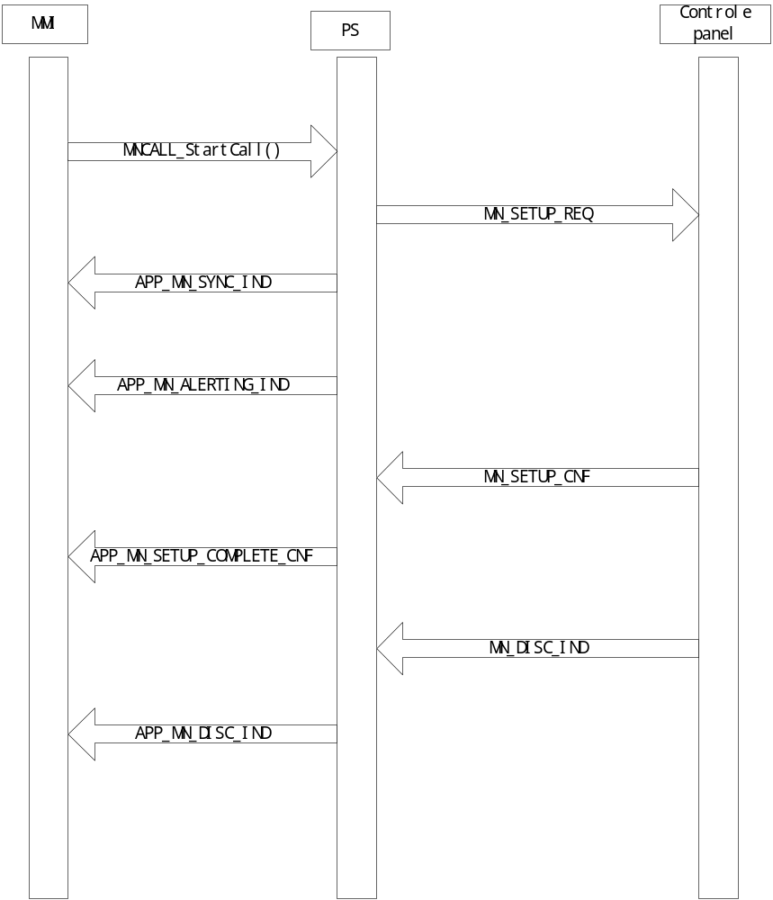

Normal MT call
